**CHAPTER ONE**

**INTRODUCTION**

* 1. **Background**

An electricity meter, electric energy meter is a device that measures the amount of electric energy consumed by a residence, business, or an electrically powered device. Electronic energy-meters are used for direct, small power measurements or for power measurements at frequencies beyond the range of electrodynamometer-type instruments. A modern digital electronic energymeter/energy meter samples the voltage and current thousands of times a second. For each sample, the voltage is multiplied by the current at the same instant; the average over at least one cycle is the real power.

* 1. **Objective**

The objective is to design and construct a low cost energy meter to measure energy by using Microcontroller.

* 1. **Methodology**

Collection of information from books and internet

Electronic components have been purchased from local market.

**CHAPTER TWO**

**Basics of Power Meter**

**2.1 Power Meter**

As we know that the rate at which electric energy is transferred by an electric circuit is called power. Power is an important electrical quantity and everything in our world today depends on having the power to keep them running. It is mandatory for a power engineer to know how much the amount of power a power plant generates and also the usage by the customer over a period of time1-2. It helps in estimation of transmission losses between the generation- distribution and distribution-consumer apparatus3. This estimation helps in power theft detection and in turn reduces the transmission losses. Measurement of electrical power may be done to measure electrical parameters of a system4. Depending upon the requirement of accuracy, time and the nature of the circuit there is a choice for method and instrument to be used in any given case of measurement5-6. In the existing power utility set up, consumers are presented with usage information only once a month with their bill7-8. The length of time between updates about power usage is far too long for a consumer to observe a changed behaviour’s effect on power usage 9-10. In addition utility bills can be convoluted in how they present usage information, and a consumer may not be able to decipher changes in their power usage from the last bill. An opportunity to educate customers on power usage is lost because of these realities.

The goal of creating more awareness about energy consumption would be optimization and reduction in energy usage by the user. This would reduce their energy costs, as well as conserve energy. There are various methods for measuring power such as single and two wattmeter methods etc. Power is rate of doing work. For DC circuits and purely resistive AC circuits, power is product of voltage and current. For reactive AC circuits the product of r.m.s values of voltage and current is termed as apparent power (VA).

Out of different microcontrollers available in the market, the one, which is single board microcontroller, descendant of the open-source wiring platform designed to make the process of using electronics in multidisciplinary projects using PIC Microcontroller.

The proposed paper uses the commercial data acquisition board (DAQ) connected to a common personal computer for high accuracy power measurements. The power digitally measured using PIC Microcontroller is displayed graphically by using LCD.

**2.2 Power Measurement**

Power is rate of expending energy. Watt is the unit for power (joule per second (J/s)). The difference in potentials between two points is equal to the energy per unit charge and this is required to move electric charge between the points, as we know, electric current measures the charge per unit time (in coulombs/second). The electric power p is given by the product of the current I and the voltage V (in joules/second = watts).

P=work done per unit time=qV/t=IV

Where: q is electric charge in coulombs, t is time in seconds, I is electric current in amperes, V is electric potential or voltage in volts.

**Energy:** The amount of energy used (or supplied) depends on the power and the time for which it is used. Energy is defined by scientists as the ability to do work. This energy is found in different forms, such as light, heat, sound, and motion. There are many forms of energy, but they can all be put into two categories: potential and kinetic.

E=P*t

Where: E= energy in watt hrs, P= power in watts, t= time taken in sec

DC Circuits: DC circuits mainly consists of only of resistive (Ohmic, or linear) loads, Joule's law can be combined with Ohm's law (V = I·R) to produce alternative expressions for the dissipated power:

P=I2R=V2/R

where R is the electrical resistance.

AC Circuits: Eenergy storage elements such as inductance and capacitance results in periodic reversals of the direction of energy flow which are alternating in nature.

Active Power: The power consumed by the resistive elements in the circuit or the portion of power flow that, averaged over a complete cycle of the AC wave form, results in net transfer of energy in one direction is known as real power ,also called as Active power. It is the power that is actually being consumed by the load.

Reactive power: Power flow due to storage elements that returns to the source in each cycle is known as reactive power.

When the voltage and current are periodic with the same fundamental frequency, the instantaneous power is also periodic with twice the fundamental frequency.

Power measurement conventional Techniques: Power measurement is done for both AC circuits and DC circuits. Power can be measured by using different methods namely: i. Using various measuring equipments. ii. By interfacing the circuit with any software.

There disadvantage of the above power measurement techniques for example In the first Ammeter measures current which flow into the voltmeter and load. Secondly circuit, Voltmeter is the device which measures voltage drop across the ammeter in addition to that dropping across the load. So the above method is not accurate.

Power measurement can also be done using software like multisim, labview etc. But, the above methods implemented either in software or in hardware. Where as in PIC MicrocontrollerPower Measurement project, the load circuit is interfaced with PIC Microcontrollerboard, and is then programmed for measuring power for laboratory purpose which is more economical as it is an open source software when compared to other software which are costlier like Labview.

**2.3 Basics of Control systems**

Control engineering is the engineering discipline that focuses on the modeling of a diverse range of dynamics systems (e.g. mechanical system )and the designer of controller that will these systems to behave in desired manner. Although such controllers need not be electrical many are and hence control engineering is often viewed as a subfield of electrical engineering .However, the falling price of microprocessor is making the actual implementation of a control system essentiality trivial .as a result focus is shifting back to the mechanical engineering is discipline, as intimate knowledge of the physical system being controlled is often desired.

Electrical circuits, digital signal processors and microcontrollers can all be used to implement control systems. Control engineering has a wide range of applications from the flight and propulsion systems of commercial airliner to the cruise control present in many modern automobiles.

In most of the causes, control engineers utilize feedback when designing control system. This is often accomplished using a PID controller system. For example .in an automobile with cruise control the vehicle’s speed is continuously monitored feedback to the system, which adjust the motor’s torque accordingly .Where there is regular feedback ,control theory can be used to determine how the system responds to such feedback .In practically all such systems stability is important and control theory can help ensure stability is achieved.

Although feedback is an important aspect of control engineering, control engineers may also work on the control of systems without feedback. This is known as open loop control .A classic example of open loop control is a washing machine that runs through a pre-determined cycle without the use of sensors.

**2.7 Modern control theory**

In constant to the frequency domain analysis of the classical control theory, modern control theory utilizes the time domain state representation, a mathematical model of physical system as a set of input, output and state variable related by first –order differential equation. To abstract from the number of inputs, output and states, the variable are expressed as vector and the differential and algebraic equation are written in matrix from (the latter only being possible when the dynamical system is linear). The state space representation (also known as the “time-domain approach”) provide a convenient and compact way to model and analyze system with multiple inputs and outputs. With inputs and outputs, we would otherwise have to write down Laplace transforms to encode all the information about system. Unlike the frequency domain approach, the use of the state space representation is not limited to systems with linear components and zero initial condition. “State space “refers to the space whose axes are the state variables. The state of the system can be representing as a vector within the space.)

**2.8 Topics in control theory**

**Stability**

The stability of a general dynamical system with no input can be desired with stability criteria. A linear system that takes n input is called bounded-input bounded-output (BIBO) stable if its output will stay bounded for any bounded input. Stability for nonlinear system that takes an input is input-to-state stability (ISS), which combines stability and a notion similar to BIBO stability. For simplicity, the following description focuses on continuous-time and discrete-time linear systems.

Mathematically, this means that for a casual linear system to be stable all of the poles of its transfer function must satisfy some criteria depending on whether a continuous or discrete time analysis is used:

* In continuous time, the Laplace transform is used to obtain the transfer function .a system is stable if the poles of this transfer function lie strictly in open left half of the complex plane (i.e. the real part of all the poles is less than zero)
* In discrete time the Z-transform is used .A system is stable if the poles this transfer function lie strictly inside the unit circle .i.e. the magnitude of the poles is less than one)

When the appreciate conditions above are satisfied a system is said to be automatically stable :the variables of an automatically stable control system always decrease from their initial value and do not show permanent oscillation, Permanent oscillation occur when a pole has a real part exactly equal to zero (in the continuous time case ) or a modules equal to one 9in the discrete time case).If a simply stable system response neither decays nor grows over time , and has no oscillation, it is marginally stable :in this case the system transfer function has no repeated poles at complex plane origin (i.e. their real and complex component is zero in the continuous time case). Oscillation are present when poles with real part equal to zero have an imaginary part not equal to zero.

Difference between the two cases is not a contradiction. The Laplace transform is in Cartesian coordinate and the Z-transform is in circler coordinates, and it can be shown that:

* The negative-real part in the Laplace domain can map into the interior of the unit circle
* The positive –real part in the Laplace domain can map into the exterior of the unit circle

If a system in question has an impulse response of

X {n} =0.5u[n]

**2.9 Controllability and observe ability**

Controllability and observe ability are main issues in the analysis of a system before deciding the best control strategy to be applied, or whether it is even possible to control or stabilize the system. Controllability is related to the possibility of forcing the system into a particular state by using and appropriate control signal. If a state is not controllable, then no signal will ever be able to control the state. If a state is not controllable, but its dynamics are stable, then the state is termed stabilize able. Observe ability instead is related to the possibility of “observing”, through output measurement, the state of a system .If a sets is not observable, the controller will never be able to determine the behavior of an unobservable state and hence cannot use it to stabilize the system. However, similar to the stabilize ability condition above, if a state cannot observed it might still be detectable.

From a geometrical point of view, looking at the states of each variable of the system to be controlled, every “bad “state of this variable must be controllable and observe able to ensure a good behavior in the closed-loop system. That is, if one of the Eigen values of the system is not both controllable and observable, this part of the dynamics will remain untouched in the closed loop system. If such an Eigen value is not stable, the dynamics of this Eigen value will be present in the closed-loop system which therefore will be unstable .Un serverable poles are not present in the transfer function realization of a state space representation ,which is why some time the latter is preferred in dynamical system analysis. Solution to problem of uncontrollable or unobservable system includes adding actuator and sensors.

**2.10 Control specification**

Several different control strategies have been devised in the past yeas .These vary from extremely general ones (PID Controller).to other dove to very particular classes of system (especially robotics or aircraft cruise control).

A control problem can have several speciations. Stability of course, is always present; the controller must ensure that the closed-loop system is stable, regardless of the open-loop stability .A poor choice of controller can even worsen the stability of the open loop system which must normally be avoided. Sometimes it would be desired to obtain particular dynamics in the closed loop

Another typical specification is the rejection of a step disturbance; include an integrator in the open loop chain (i.e. directly before the system under control) easily achieves this. Other classes of disturbance need different types of sub-systems to be included.

Other “classical” control theory specification regard the time response of the closed-loop system: these include the rise time (the time needed by the control system to reach the desired value after a perturbation), peak overshoot (the highest value reached by response before reaching the desired value)and others (setting time, quarter-decay).Frequency domain specification is usually related to robustness (see after).

Modern performance assessments use some variation of integrated tracking error (IAE, ISA, and CQI)

**2.11 Model identification and robustness**

A control system must always have some robustness property. A robust controller is such that its properties do not change much if applied to a system slightly different from a mathematical one used for its synthesis. This specification is important: no real physical system truly behaves like the series of different equation used to represent it mathematically. Typically a simpler mathematical model is chosen in order to simplify calculation; otherwise the rue system dynamics can be so complicated that a complete model is impossible.

**System Identification**

The process of determining the equation hat govern the model’s dynamics is called system identification. This can be done off-liner; for example, executing a series of measure from which to calculate an approximate mathematical model, typically its transfer function of matrix .Such identification from the output, however, cannot take account of unobservable dynamics. Sometime the model is built directly starting from known physical equation; for example, in the case of a mass-spring-damper system we know that a “complete” model is used in designing the controller, all the parameter include in these equation (called “nominal parameters) are never know with absolute precision; the control system will have to behave correctly even when connected to physical system with true parameter values away from nominal. Some advanced control techniques include an “on-line” identification process (see later0.The parameter of the model are calculated (“identified”) while the controller itself is running; in this way, if a drastic variation of the parameters ensues (for example, if the robot’s arm release a weight).the controller will adjust itself consequently in order to ensure the correct performance.

**Analysis**

Analysis of the robustness of a SISO control can be performed in the frequency domain considering the system’s transfer function and using Nyquist and Bode diagram. Topics include gain and phase margin and amplitude margin. For MIMO and in general, more complicated control system one must consider the theoretical result devised for each control technique (see next section); i.e. If particular robustness qualities are needed, the engineer must shift his attention to a control technique including them in its properties.

**Hierarchical control**

A Hierarchical control system is a type o f a control system in which a set of devices and governing software is arranged in a hierarchical tree. When the link in the tree are implement by a computer network, then that hierarchical control system is also a form of network control system.

**Intelligent control**

Intelligent control uses various AL computing approaches like neural networks, Bayesian probability, fuzzy logic, machine learning, evolutionary computation and genetic algorithms to control a dynamic system.

**Optimal control**

Optimal control is a particular control technique in which the control signal optimizes a certain “cost index”: for example, in the case of a satellite, the jet thrusts needed to bring it to desired trajectory that consume the least amount of fuel .Two optimal control design methods have been widely used in industrial application, as it has been shown they can controller, MPC systems are the most widely used control technique in process control.

**Robust Control**

Robust Control deals explicitly with uncertainly in its approach to controller design .Controllers designed using *Robust Control* methods to be able to cope with small difference between the true system and the nominal model used for design. The early method of Bode and others were fairly robust: the state-space methods in the 1960s and 1970s were sometimes found to lock robustness. A modern example of a Robust Control technique is H-infinity loop-shaping developed by Duncan McFarlane and Keith Glover of Cambridge University .United Kingdom. Robust methods aim to achieve Robust Performance and/or stability in the presence of small modeling errors.

**CHAPTER THREE**

**PIC Microcontroller**

**3.1 Microcontroller**

A Microcontroller is a small computer on a single integrated circuit consisting internally of a relatively simple CPU, clock, timers, I/O ports, and memory. Program memory is in the form of NOR flash or OTP ROM is also often included on chip, as well as a typically small amount of RAM. Microcontrollers are designed for small or dedicated applications. Thus, in contrast to the microprocessors used in personal computers and other high-performance or general purpose applications, simplicity is emphasized. Some microcontrollers may use four-bit words and operate at clock rate frequencies as low as 4 kHz, some other may use eight bit and operate from a clock frequency of 20 kHz as this is adequate for many typical such applications, enabling low power consumption. They will generally have the ability to retain functionality while waiting for an event such as a button press or other interrupt; power consumption while sleeping (CPU clock and most peripherals off) may be just nano watts, making many of them well suited for long lasting battery applications. Other microcontrollers may serve performance-critical roles, where they may need to act more like a digital signal processor (DSP), with higher clock speeds and power consumption. Microcontrollers are used in automatically controlled products and devices, such as automobile engine control systems, remote controls, office machines, appliances, power tools, and toys. By reducing the size and cost compared to a design that uses a separate microprocessor, memory, and input/output devices, microcontrollers make it economical to digitally control even more devices and processes. Mixed signal microcontrollers are common, integrating analog components needed to control non-digital electronic systems. A designer will use a Microcontroller to:

* Gather input from various sensors.
* Process this input into a set of actions.
* Use the output mechanisms on the Microcontroller to do something useful.

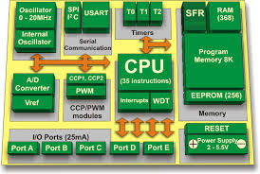

**3.2 PIC16F877A Microcontroller**

PIC16F877A Microcontroller, one of the most popular microcontrollers on the market. It is combined into an easy to use and ready to run board complete with all the necessary components for plugging directly into the system. This powerful (200 nanosecond instruction execution) yet easy-to-program (only 35 single word instructions) CMOS FLASH-based 8-bit microcontroller packs Microchip's powerful PIC architecture into 28-pin package and is upwards compatible with the PIC16C5X, PIC12CXXX and PIC16C7X devices. The PIC16F73 features 5 channels of 8-bit Analog-to-Digital (A/D) converter with 2 additional timers, 2 capture/compare/PWM functions and the synchronous serial port can be configured as either 3-wire Serial Peripheral Interface (SPI™) or the 2-wire Inter-Integrated Circuit (I²C™) bus and a Universal Asynchronous Receiver Transmitter (USART). All of these features make it ideal for more advanced level A/D applications in automotive, industrial, appliances and consumer applications.

**3.3 High Performance RISC CPU Features**

* High performance RISC CPU.
* Only 35 single word instructions to learn.
* All single cycle instructions except for program branches which are two-cycle.
* Operating speed: DC - 20 MHz clock input DC - 200 ns instruction cycle.
* Up to 8K x 14 words of FLASH Program Memory, Up to 368 x 8 bytes of Data Memory (RAM).
* Pin out compatible to the PIC16C73B/74B/76/77.
* Pin out compatible to the PIC16F873/874/876/877.
* Interrupt capability (up to 12 sources).
* Eight level deep hardware stack.
* Direct, Indirect and Relative Addressing modes.
* Processor read access to program memory.

**3.4 Peripheral Features**

* Timer0: 8-bit timer/counter with 8-bit presale.
* Timer1:16-bit timer/counter with presale can be incremented during SLEEP via external crystal/clock.
* Timer2: 8-bit timer/counter with 8-bit period registers, presale and post scalar.
* Two Capture, Compare, PWM modules.
* Capture is 16-bit, max. Resolution is 12.5 ns.
* Compare is 16-bit, max. Resolution is 200 ns.
* PWM max. Resolution is 10-bit.
* 8-bit, up to 8-channel Analog-to-Digital converter.
* Synchronous Serial Port (SSP) with SPI (Master mode) and I2C (Slave).
* Universal Synchronous Asynchronous Receiver Transmitter (USART/SCI).
* Parallel Slave Port (PSP), 8-bits wide with external RD, WR and CS controls (40/44-pin only).
* Brown-out detection circuitry for Brown-out Reset (BOR).

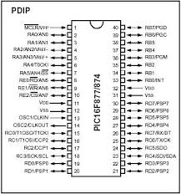**3.5 Pin Diagram of PIC 16F877A**

Figure 3.1: Pin diagram of PIC 16F877A IC

**3.6 Some advantages of 16F877A**

* Low-power, high-speed Flash/EEPROM technology.
* Fully static design.
* Wide operating voltage range (2.0V to 5.5V).
* Commercial and Industrial temperature range.
* Low-power consumption.

**3.7 Reason for selecting PIC 16F819**

It has an operating range of dc to 20 MHZ frequency. Each port can be used as input-output port. Contain internal ADC, comparator. That’s why we select this microcontroller. It has enriched instruction set and easy to use them. We collect the related software and those are easy to use.

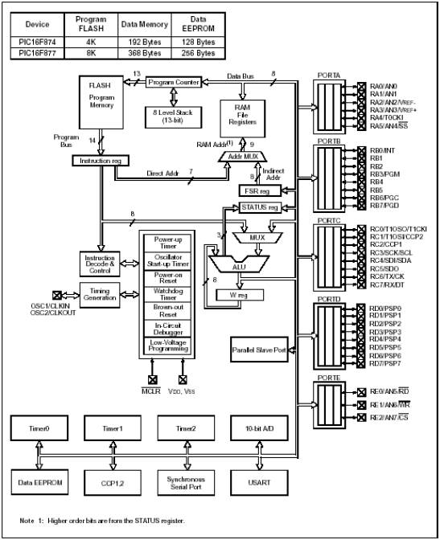**3.8 PIC 16F877A Block Diagram**

Figure 3.2: Block diagram of PIC 16F877A

**CHAPTER FOUR**

**VOLTAGE AND CURRENT SENSING**

**4.1 Introduction**

PIC Microcontroller analog inputs can be used to measure DC voltage between 0 and 5V (on 5V Arduinos such as the PIC Microcontroller when using the standard 5V analog reference voltage). The range over which the PIC Microcontroller can measure voltage can be increased by using two resistors to create a voltage divider. The voltage divider decreases the voltage being measured to within the range of the PIC Microcontroller analog inputs. Code in the PIC Microcontroller sketch is then used to calculate the actual voltage being measured. This allows voltages greater than 5V to be measured.

**4.2 Principle of Operation:**

A digital multimeter set to measure DC voltage will typically have an input impedance of 10MΩ or greater. What this means is that the resistance between the two multimeter probes is 10MΩ or more. A high input impedance for a voltmeter (or multimeter on the voltage scale) is desirable as the higher the input impedance, the less likely the multimeter will influence or change the circuit being measured. Measuring voltage across a component in a circuit with a multimeter that has an input impedance of 10M ohms, is the same as connecting a 10M ohm resistor across the component. If a voltmeter has a low input impedance, say 10kΩ and a voltage across a 10kΩ resistor is being measured, the multimeter is effectively changing the resistor value to 5kΩ (two 10k resistors in parallel = 5k resistance). The multimeter therefore has changed the circuit and possibly the voltage being measured. So a high input impedance is desirable in our voltage divider circuit if the impedance of this "voltmeter" is going to influence the circuit being measured. As a general rule though, a high input impedance device will generally pick up more noise or interference (EMI) than a low input impedance device.

**4.3 Voltage Divider Circuit**

A voltage divider circuit consisting of two resistors in series will divide the input voltage to bring it within the range of the PIC Microcontroller analog inputs. The circuit shown below will divide the input voltage by 11 (from the battery as the example input voltage being measured). The circuit with the particular values shown has an input impedance of 1MΩ + 100kΩ = 1.1MΩ and is suitable for measuring DC voltages up to about 50V.

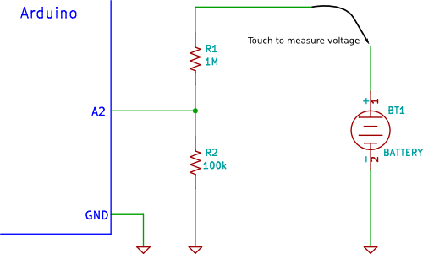

**4.4 Safety Measures**

*Common Ground*

If the PIC Microcontrolleris powered from an external power supply or a USB cable (i.e. not powered by a isolated battery or other isolated power supply) the circuit may share a common ground or 0V connection with the circuit under test.

If the GND connection of the PIC Microcontrolleris connected to any other part of the circuit under test except GND, then this is the same as shorting that part of the circuit to GND.

The GND of the PIC Microcontrolleris like the negative or common (COM) lead of a multimeter, except that it should be considered to be permanently connected to the GND of the circuit under test for safety, unless the PIC Microcontrolleror the circuit under test is completely isolated and "floating".

*Input Protection:*

The resistor values in the circuit diagram above provide some over-voltage protection when measuring low voltages such as 5V, 9V or 12V. So if a voltage of say 30V is accidentally measured, it will not blow the PIC Microcontroller analog input pin. Any voltage higher than about 55V could damage the Arduino. The point on the resistor divider network connected to the the PIC Microcontroller analog pin is equivalent to the input voltage divided by 11, so 55V ÷ 11 = 5V. In other words, when measuring 55V, the PIC Microcontroller analog pin will be at its maximum voltage of 5V. Providing this basic over-voltage protection is at the expense of not using the full 10-bit range of the analog input ADC if only lower voltages are to be measured, but changes of about 0.054V can still be measured. No other protection for voltage spikes, reverse voltage or voltages higher than 55V is shown in the circuit.

**4.5 Calibration**

A more accurate voltage could be obtained by using a precision reference voltage for the ADC and using 1% tolerance resistors or better. Another way to obtain a more accurate reading is to calibrate the circuit. Calibration can be done by measuring the actual value of the reference voltage and the actual values of the voltage divider resistors. These values can then be used in the calculations in the PIC Microcontroller sketch code.

Each PIC Microcontroller and set of resistors would need to be individually calibrated because the voltage from the 5V regulator and the resistance of the voltage divider resistors will probably be slightly different for each PIC Microcontroller and set of resistors.

Connect a stable power supply, such as a 9V battery across the resistor network. Measure the voltage across both resistors together i.e. measure the battery voltage.

Now measure the voltage across the 100k resistor (R2) i.e. between PIC Microcontroller pin A3 and GND. The voltage divider factor is calculated by dividing the first voltage by the second voltage or: dividing factor = input voltage ÷ output voltage. For example, if the first or input voltage measured is 10.02V and the second or output voltage is 0.9V, then the division factor is: 10.02 ÷ 0.9 = 11.133

**4.6 Measure DC Current with Microcontroller**

Microcontrollers usually don’t have specific ports for measuring currents, but they do have ADC channels through which you can measure analog voltages of a certain range. This means a dc current can be indirectly measured by a microcontroller’s ADC channel by first converting the current into voltage. The simplest way of doing this is to place a resistance in series with the current path and measure the voltage drop across it. But hold on, if you place an additional resistance in the circuit, it will affect the original current. Therefore, we need to use a very small value resistance so that it’s effect in the circuit current won’t be significant.

The resistance can be measured directly with a digital multimeter. This measurement may have higher uncertainty as it is very small and most multimeter does not show values beyond 1 decimal digit. The resistance can also be measured using Ohm’s law. Next, measure the voltage across Rs and current through it separately using the multimeter. In my case, we found the measured voltage and current values to be 24.1 mV and 84.3 mA, respectively. This gives the resistance of the coil is about 0.286.

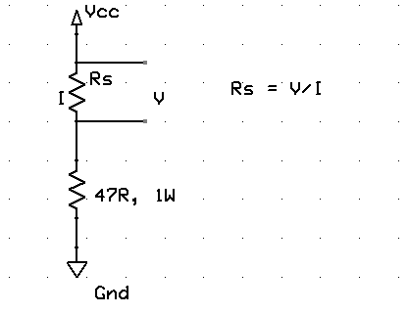

Now, suppose that the range of current to be measured using this coil resistance is from 0-2 A. Then the voltage drop across the coil resistance will be somewhere from 0 – 0.57 V. Because of its low dynamic range, this voltage signal may not be accurately measured with a microcontroller’s ADC module. So this requires some sort of voltage scaling. One way to achieve that is by using an operational amplifier circuit as shown below.

In the circuit, Rs is the low value current sensing resistor (our coil resistor) which is connected in series with the load resistor. Our objective is to derive the load current (I). The low voltage drop across Rs is amplified by the non-inverting amplifier. The gain of the amplifier is set by Rf and Ri resistors. For Rf = 10 K, and Ri = 1.3 K, the gain of the amplifier would be about 8.7. This is enough to linearly scale Vs (0-0.57 V) to Vo (0- 5 V). Now you have 0-5 V voltage signal that corresponds to 0-2 A current through Rs. This voltage signal is now more appropriate for ADC conversion with Vref = 5 V.

Vo = 8.7 x I x Rs = 2.49I (Rs = 0.286)

=> I = Vo/2.49.

For 10-bit ADC with Vref = 5 V, resolution = 5/1024 = 0.0049 V. For input signal Vo, the ADC O/P will be Vo x 0.0049. Thus,

I = ADC O/P x 0.0049/2.49 = 0.00197 x ADC O/P

The current resolution would be therefore 0.00197 A

**CHAPTER FIVE**

**RELAY**

**5.1 Introduction**

A **relay** is an [electrically](http://en.wikipedia.org/wiki/Electric) operated [switch](http://en.wikipedia.org/wiki/Switch). Many relays use an [electromagnet](http://en.wikipedia.org/wiki/Electromagnet) to mechanically operate a switch, but other operating principles are also used, such as [solid-state relays](http://en.wikipedia.org/wiki/Solid-state_relay). Relays are used where it is necessary to control a circuit by a low-power signal (with complete electrical isolation between control and controlled circuits), or where several circuits must be controlled by one signal. The first relays were used in long distance [telegraph](http://en.wikipedia.org/wiki/Electrical_telegraph) circuits as amplifiers: they repeated the signal coming in from one circuit and re-transmitted it on another circuit. Relays were used extensively in telephone exchanges and early computers to perform logical operations.

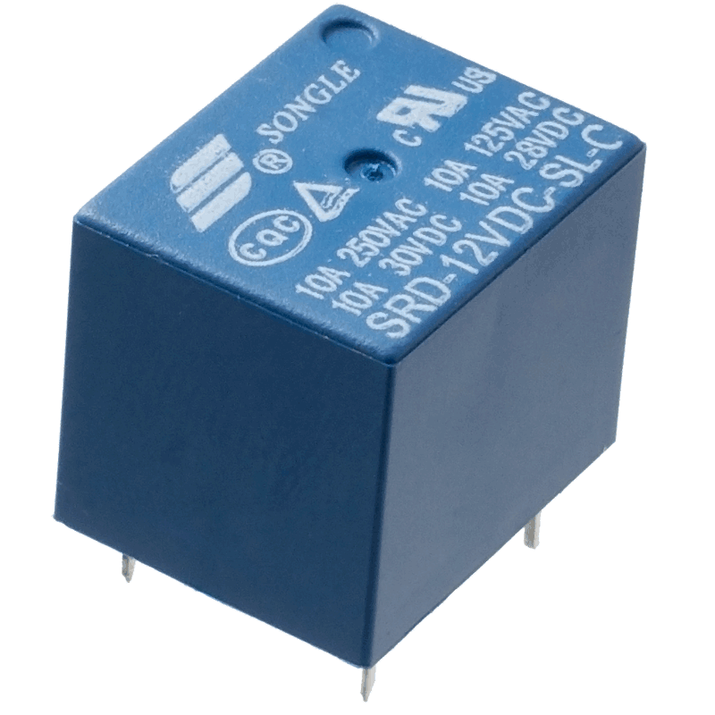

**5.2 Types of Relay:**

There are various types of relays. They are as follows:

### **1. Latching Relay**

Latching relays are also called impulse relays. They work in the bistable mode, and thus have two relaxing states. They are also called keep relays or stay relays because as soon as the current towards this relay is switched off, the relay continues the process that it was doing in the last state. This can be achieved only with a solenoid which is operating in a ratchet and cam mechanism.  It can also be done by an over-centre spring mechanism or a permanent magnet mechanism in which, when the coil is kept in the relaxed point, the over-centre spring holds the armature and the contacts in the right spot. This can also be done with the help of a remanent core. In the ratchet and cam method, power consumption occurs only for a particular time. Hence it is more advantageous than the others.

### **2. Reed Relay**

These types of relays have been given more importance in the contacts. In order to protect them from atmospheric protection they are safely kept inside a vacuum or inert gas.  Though these types of relays have a very low switching current and voltage ratings, they are famous for their switching speeds.

### **3. Polarized Relay**

This type of relay has been given more importance on its sensitivity. These relays have been used since the invention of telephones. They played very important roles in early telephone exchanges and also in detecting telegraphic distortion. The sensitivity of these relays are very easy to adjust as the armature of the relay is placed between the poles of a permanent magnet.

### **4. Buchholz Relay**

This relay is actually used as a safety device. They are used for knowing the amount of gas present in large oil-filled transformers. They are designed in such a way that they produce a warning if it senses either the slow production of gas or fast production of gas in the transformer oil.

### **5. Overload protection Relay**

As the name implies, these relays are used to prevent the electric motors from damage by over current and short circuits. For this the heating element is kept in series with the motor. Thus when over heat occurs the bi-metallic strip connected to the motor heats up and in turn releases a spring to operate the contacts of the relay.

### **6. Mercury Wetted Relay**

This relay is almost similar to the reed relay explained earlier. The only difference is that instead of inert gases, the contacts are wetted with mercury. This makes them more position sensitive and also expensive. They have to be vertically mounted for any operation. They have very low contact resistance and so can be used for timing applications. Due to these factors, this relay is not used frequently.

### **7. Machine Tool Relay**

This is one of the most famous industrial relay. They are mainly used for the controlling of all kinds of machines. They have a number of contacts with easily replaceable coils. This enabkes them to be easily converted from NO contact to NC contact. Many types of these relays can easily be setup in a control panel. Though they are very useful in industrial applications, the invention of PLC has made them farther away from industries.

### **8. Contacor Relay**

This is one of the most heavy load relay ever used. They are mainly used in switching electric motors. They have a wide range of current ratings from a few amps to hundreds. The contacts of these relays are usually made with alloys containing a small percentage of silver. This is done so as to avoid the hazardous effects of arcing. These type of relays are mainly categorized in the rough use areas. So, they produce loud noises while operated and hence cannot be used in places where noise is a problem.

### **9. Solid State relay**

SSR relays, as its name implies are designed with the help of solid state components. As they do not have any moving objects in their design they are known for their high reliability.

### **10. Solid State Contactor Relay**

These relays combine both the features of solid state relays and contactor relays. As a result they have a number of advantages. They have a very good heat sink and can be designed for the correct on-off cycles. They are mainly controlled with the help of PLC, micro-processors or microcontrollers.

**5.3 Applications of Relay:**

* Relays are used to realize logic functions. They play a very important role in providing safety critical logic.
* Relays are used to provide time delay functions. They are used to time the delay open and delay close of contacts.
* Relays are used to control high voltage circuits with the help of low voltage signals. Similarly they are used to control high current circuits with the help of low current signals.
* They are also used as protective relays. By this function all the faults during transmission and reception can be detected and isolated.

**5.4 Working Principle:**

An electromagnet relay is a coil of iron that works as a magnet when electricity flows through it. It links two circuits of which on one side is the input circuit and the other is the output circuit. Electromagnetic relay has one or two sets of contacts which are attached to the armature and a coil. When voltage is introduced to the coil, current flows through it which generates magnetic field. Due to this the inner circuit turns on and activates the magnet which creates a magnetic field around it. Due to electromagnetic induction it pulls the metal bar in and closes the switch thus allowing a bigger current to flow to the outer circuit. When the voltage is stopped, the magnetic field collapses and the switch opens up and no electric current flows. A diode is placed across the relay coil to protect the components in the relay so that they do not get damaged when the voltage is passed and the coil has no place to go. A diode is mostly placed in case of DC loads whereas varistor is used in place of diode in case of AC loads. This varistor is connected to anode and cathode at two ends like a Zener diode.

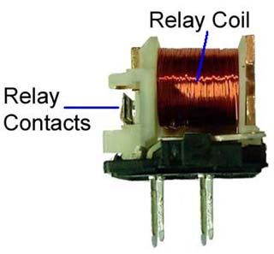The magnetic field is generated by a coil consisting of copper wire wound in layers around the bobbin in which there is an iron core. If voltage is applied to the coil terminals a current (Ohms law I=U/R) flowing through the coil generates a magnetic field and hence magnetic flux. This induced magnetic field/flux is directly proportional to the coil current and the number of turns of the coil (H=n x I, H=magnetic field, n=number of turns, I=coil current).   
When the magnetic field is strong enough, it will pull in the armature towards the core, closing the magnetic circuit and actuating the armature. The moving armature directly or indirectly operates the relay contacts. Although the current is the primary factor in generating flux and the pull force in magnetic system, it is common practice to work with voltages to select and specify the relay coil.

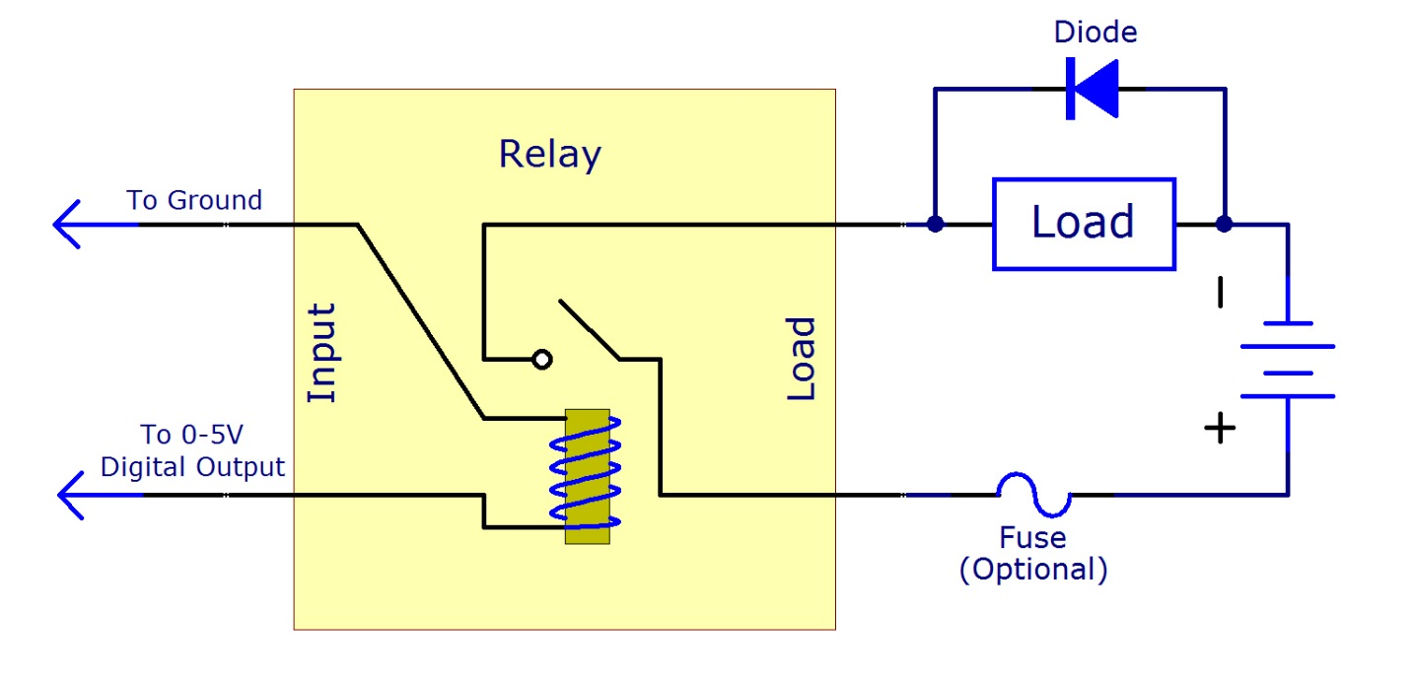**5.6 Circuit diagram:**

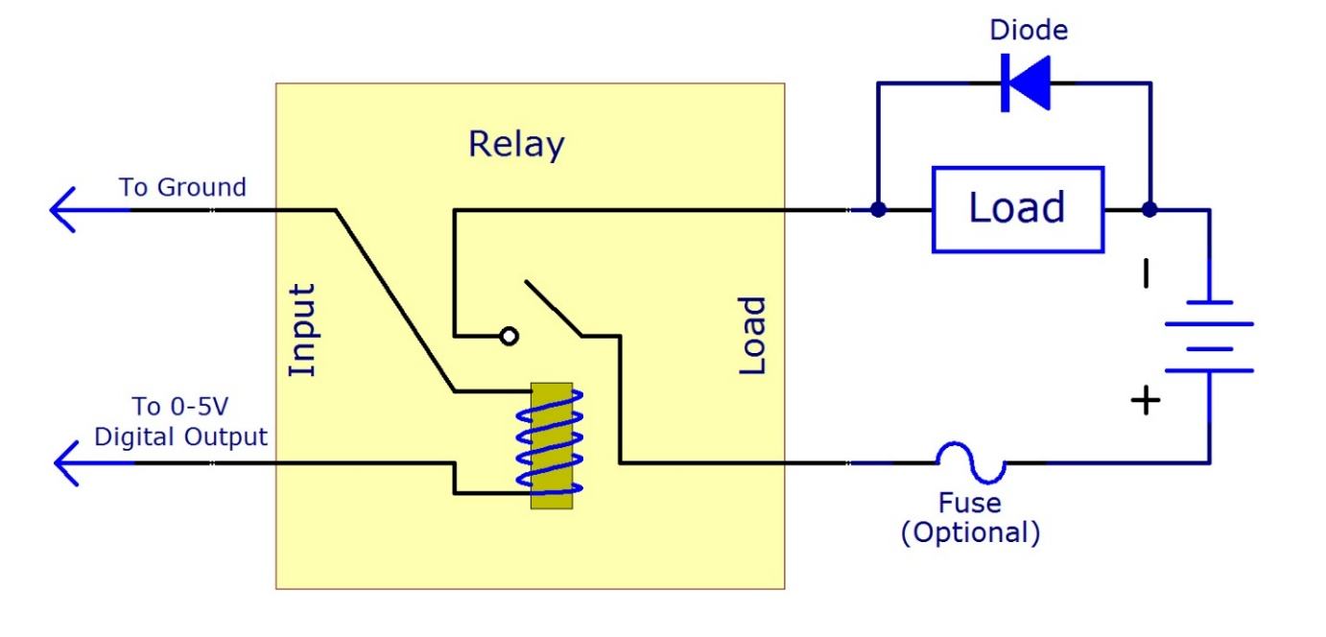

**CHAPTER SIX**

**TRANSFORMER**

**6.1 INTRODUCTION**

A **transformer** is an electrical device that transfers energy between two or more circuits through [electromagnetic induction](http://en.wikipedia.org/wiki/Electromagnetic_induction). A varying current in the transformer's primary winding creates a varying [magnetic flux](http://en.wikipedia.org/wiki/Magnetic_flux) in the core and a varying magnetic field impinging on the secondary winding. This varying [magnetic field](http://en.wikipedia.org/wiki/Magnetic_field) at the secondary induces a varying [electromotive force](http://en.wikipedia.org/wiki/Electromotive_force) (emf) or voltage in the secondary winding. Making use of [Faraday's Law](http://en.wikipedia.org/wiki/Faraday%27s_law_of_induction) in conjunction with high [magnetic permeability](http://en.wikipedia.org/wiki/Permeability_(electromagnetism)) core properties, transformers can thus be designed to efficiently change [AC](http://en.wikipedia.org/wiki/Alternating_current) voltages from one voltage level to another within power networks. Transformers range in size from [RF](http://en.wikipedia.org/wiki/RF) transformers less than a cubic centimetre in volume to units interconnecting the [power grid](http://en.wikipedia.org/wiki/Power_grid) weighing hundreds of tons. A wide range of transformer designs is encountered in electronic and electric power applications. Since the invention in 1885 of the first constant [potential](http://en.wikipedia.org/wiki/Potential_energy) transformer, transformers have become essential for the AC [transmission](http://en.wikipedia.org/wiki/Electric_power_transmission), [distribution](http://en.wikipedia.org/wiki/Electric_power_distribution), and utilization of electrical energy.

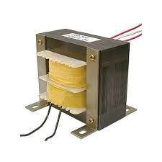

**6.2 TYPES OF TRNASFORMER:**

[**Autotransformers**](http://www.thomasnet.com/products/autotransformers-2324408-1.html?WTZO=NTKG+Body+Link)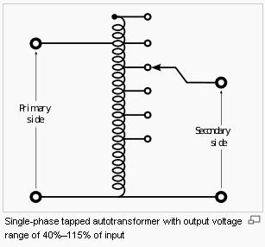

Autotransformers are different from traditional transformers because autotransformers share a common winding. On each end of the transformer core is an end terminal for the winding, but there is also a second winding that connects at a key intermediary point, forming a third terminal. The first and second terminals conduct the primary voltage, while the third terminal works alongside either the first or second terminal to provide a secondary form of voltage. The first and second terminals have many matching turns in the winding. Voltage is the same for each turn in the first and second terminal. An adaptable autotransformer is another option for this process. By uncovering part of the second winding and using a sliding brush as the second terminal, the number of turns can be varied, thus altering voltage (see image on right).

**Polyphase Transformers**

This type of transformer is commonly associated with three phase electric power, which is a common method of transmitting large amounts of high voltage power, such as the national power grid. In this system, three separate wires carry alternating currents of the same frequency, but they reach their peak at different times, thus resulting in a continuous power flow. Occasionally these “three-phase” systems have a neutral wire, depending on the application. Other times, all three phases can be incorporated into one, multiphase transformer. This would require the unification and connection of magnetic circuits so as to encompass the three-phase transmission. Winding patterns can vary and so can the phases of a polyphase transformer.

**Leakage Transformer**

Leakage transformers have a loose binding between the primary and secondary winding, which leads to a large increase in the amount of inductance leakage. All currents are kept low with leakage transformers, which helps prevent overload. They are useful in applications such as arc welding and certain high-voltage lamps, as well as in the extremely low-voltage applications found in some children’s toys.

**Resonant Transformer**

As a type of leakage transformer, resonant transformers depend on the loose pairing of the primary and secondary winding, and on external capacitors to work in combination with the second winding. They can effectively transmit high voltages, and are useful in recovering data from certain radio wave frequency levels.

**Audio Transformer**

Originally found in early telephone systems, audio transformers help isolate potential interference and send one signal through multiple electrical circuits. Modern telephone systems still use audio transformers, but they are also found in audio systems where they transmit analog signals between systems. Because these transformers can serve multiple functions, such as preventing interference, splitting a signal, or combining signals, they are found in numerous applications. Amplifiers, loudspeakers, and microphones all depend on audio [transformers](http://www.thomasnet.com/products/transformers-87000808-1.html?WTZO=NTKG+Body+Link) in order to properly perform.

**6.3 MULTITAP TRANSFORMER:**

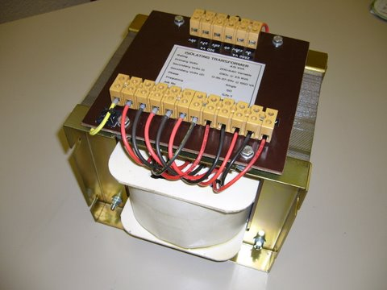

A Multi Tap Transformer is a step up or down transformer that has multiple taps on either the primary winding or the secondary winding. A Multi Tap Transformer provides flexibility in your input and output voltage requirements.

Multi Tap Transformers are used in heating element applications. The resistance of the heating elements increases with age which results in reduced current thru the heating element. To restore the heating element current back to its original value, the voltage applied to the heating element must be increased. Multi tap transformer connections provide the additional taps to compensate for the change.

Multi tap transformers are also used in compensating for the variation of input power voltages to a customer facility. Input power to the equipment changes due to the load conditions as well as the proximity of the utility power to the customer facility and many other causes. This results in a mismatched input voltage to a customer facility. The multi tap transformer wiring configurations would be able to provide necessary taps to compensate for the variation of input voltages.

L/C Magnetics can provide Multi Tap Transformers as an open core and coil unit or enclosed in a corrosion resistant power coated enclosure. We can also install the transformer in a NEMA 4 enclosure or a stainless steel enclosure. L/C Magnetics builds custom designed multi tap transformers with taps on the primary side and taps on the secondary side. The transformers can be used for single phase or three phase applications. Click the photos for additional details. If these units do not meet your exact requirements, we will be glad to offer a redesigned transformer.

**6.4 Diagram Description of Multitap Transformer:**

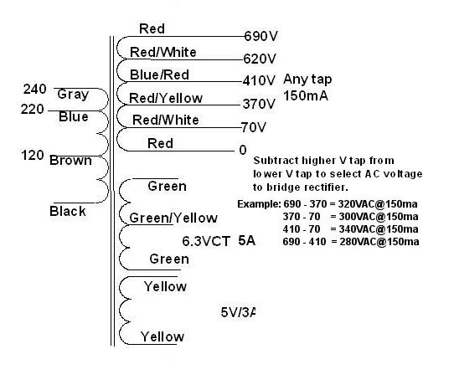

**6.5 APPLICATIONS OF TRANSFORMER:**

The most important uses and application of Transformer are:

* It can rise or lower the level of level of Voltage or Current in an AC Circuit.
* It can increase or decrease the value of capacitor, an inductor or resistance in an AC circuit. It can thus act as an impedance transferring device.
* It can be used to prevent DC from passing from one circuit to the other.
* It can isolate two circuits electrically.

**CHAPTER SEVEN**

**RTC MODULE & LCD**

**7.1 Introduction to RTC Module**

A Real Time Clock Module with battery backup using the easy to use DS1302 chip. The DS1302 chip uses a simple serial interface and example code is available for Arduino, Raspberry Pi and many others. Although keeping time can be done without an RTC,using one has benefits:

* Low power consumption (important when running from alternate power)
* Frees the main system for time-critical tasks
* Sometimes more accurate than other methods

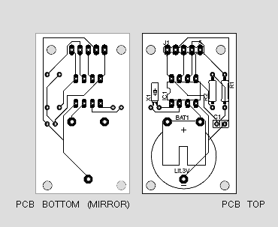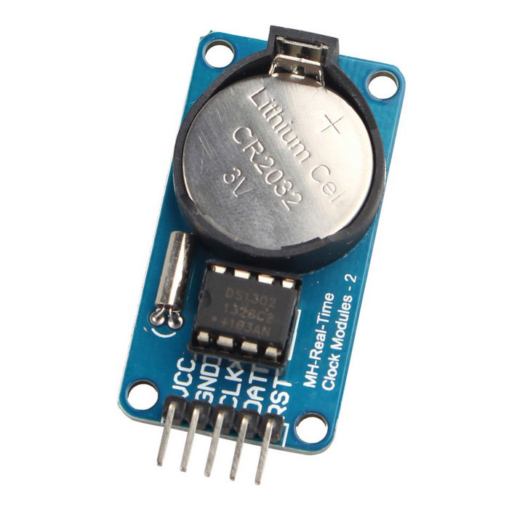

### **7.2 Powering the DS1307**

The RTC module breakout board does not include any voltage regulation, so power supplied to the “5V” pin should be kept within the DS1307’s recommended operating range: **4.5 to 5.5V**. The chip is designed to be as low-power as possible. During communication bursts, the chip may consume upward of 1.5mA, but it will run at closer to 200µA. When the primary power supply is removed and the chip is running off its backup battery, it will consume between 300-800nA (depending on whether the SQW pins is configured as an output).

A [GPS](https://en.wikipedia.org/wiki/Global_Positioning_System) receiver can shorten its startup time by comparing the current time, according to its RTC, with the time at which it last had a valid signal. If it has been less than a few hours, then the previous [ephemeris](https://en.wikipedia.org/wiki/Ephemeris) is still usable. RTCs often have an alternate source of power, so they can continue to keep time while the primary source of power is off or unavailable. This alternate source of power is normally a [lithium battery](https://en.wikipedia.org/wiki/Lithium_battery) in older systems, but some newer systems use a [supercapacitor](https://en.wikipedia.org/wiki/Supercapacitor" \o "Supercapacitor), because they are rechargeable and can be [soldered](https://en.wikipedia.org/wiki/Soldering). The alternate power source can also supply power to [battery backed RAM](https://en.wikipedia.org/wiki/Nonvolatile_BIOS_memory). Most RTCs use a [crystal oscillator](https://en.wikipedia.org/wiki/Crystal_oscillator), but some use the [power line frequency](https://en.wikipedia.org/wiki/Utility_frequency). In many cases, the oscillator's frequency is 32.768 kHz. This is the same frequency used in [quartz clocks and watches](https://en.wikipedia.org/wiki/Quartz_clock), and for the same reasons, namely that the frequency is exactly 215 cycles per second, which is a convenient rate to use with simple binary counter circuits.

**7.3 Introduction of LCD (Liquid Crystal Display):**

LCD (Liquid Crystal Display) screen is an electronic display module and find a wide range of applications. A 16x2 LCD display is very basic module and is very commonly used in various devices and circuits.  It is available in a 16 pin package with back light, contrast adjustment function and each dot matrix has 5×8 dot resolution

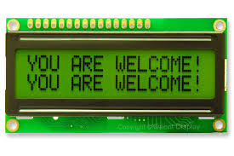

A **16x2 LCD** means it can display 16 characters per line and there are 2 such lines. In this LCD each character is displayed in 5x7 pixel matrix. This LCD has two registers, namely, Command and Data. The command register stores the command instructions given to the LCD. A command is an instruction given to LCD to do a predefined task like initializing it, clearing its screen, setting the cursor position, controlling display etc. The data register stores the data to be displayed on the LCD. The data is the ASCII value of the character to be displayed on the LCD. Click to learn more about internal structure of a [LCD](http://www.engineersgarage.com/insight/how-lcd-works)

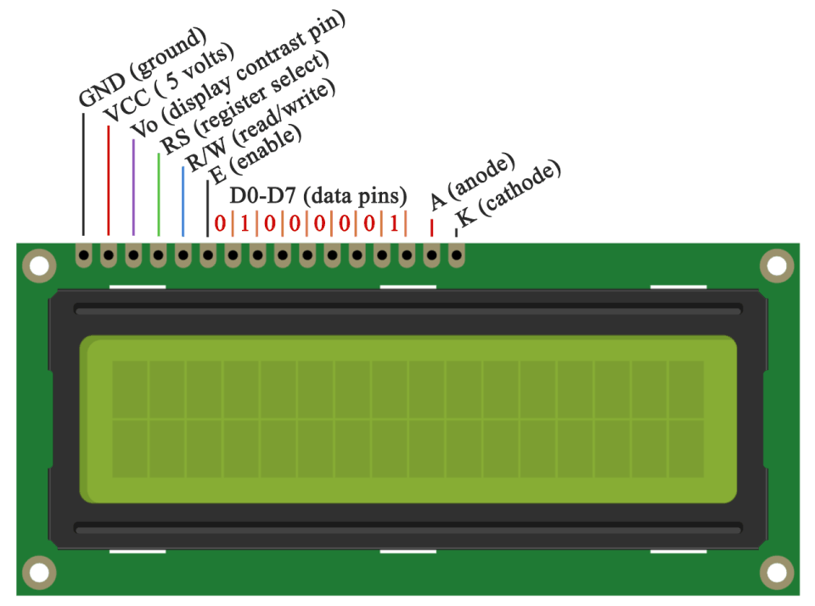

**CHAPTER EIGHT**

**WORKING PRINCIPLE**

**8.1 Working Principle**

To measure the power, it is important to measure the current and voltage from the appliance. At first, step down transformer is used to convert the voltage from 220V to 12V AC. Then this voltage is rectified and filtered before connecting to the Microcontroller because Microcontroller only works at 5V DC. After that, Voltage and Current is measured by the ADC port of the Microcontroller. Then power is calculated form the formulae P= V * I by the Microcontroller and finally result is displayed in the LCD. Also, time is calculated using RTC Module. Based on time and power, load is controlled automatically.

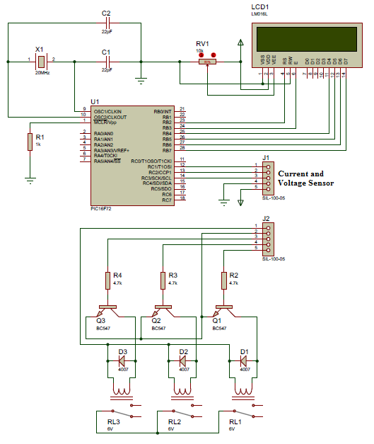**8.2 Circuit Diagram**

**8.2 Circuit Diagram**

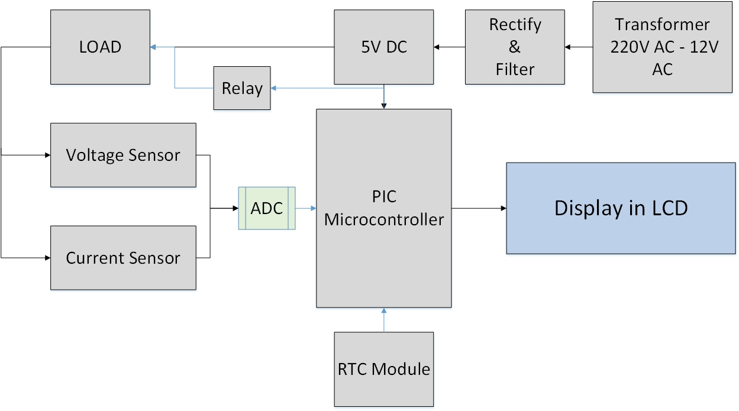

**8.4 Microcontroller and control unit**

A control unit is a main part of the system that controls its operation. In this device PIC Microcontroller is used as the controller unit which controls the relay.

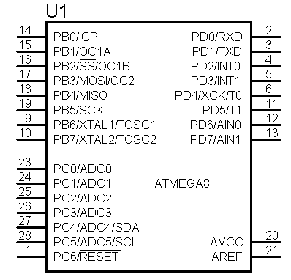

Fig 5.7: PIC Microcontroller

**8.5 Power Circuit**

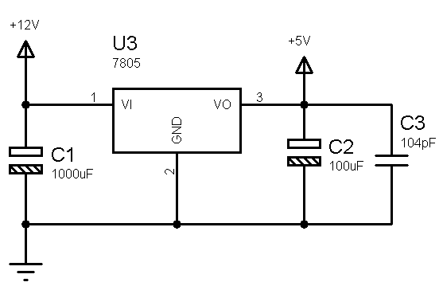

Fig 5.8: Power Circuit for Power Management

Power supply is a very important part of electronic circuit. For power supply, one dc charger has been used for driven relay.

**8.5 Apparatus**

1. Resistor: R1=15KΩ, R3=10KΩ, R3=150KΩ, R4=4.7KΩ, R5=1KΩ, R6=18KΩ, and a 100KΩ variable resistor, R8 =1KΩ.
2. Capacitor: C1=10µF 35V , C3=0.01µF, C8=100µF
3. RS 232 protocol
4. PIC Microcontroller
5. Diode
6. Microcontroller PIC
7. LCD
8. Relay
9. RTC Module

**8.6 Applications**

* The digital LCD power meters can be used for domestic purposes too apart from being used for commercial purposes.
* Power meter is used to measure the power consumption of an Electric circuit or an appliance which is connected to the supply.
* Auto control power meter is used to save energy.

**8.7 Advantages**

* Digital power meters are more accurate and precise.
* The readings are displayed in a numerical form.
* The digital power meter control load automatically according to its time and power.

**8.8 List of Component with Price**

|  |  |  |  |
| --- | --- | --- | --- |
| **Name** | **Quantity** | **Unit Price** | **Total Price** |
| Microcontroller PIC16F4550 | 1 | 200 | 200 |
| Printed  Circuit Board | 2 | 300 | 600 |
| Transistor and Resistor | 5 | 30 | 150 |
| Transformer | 1 | 60 | 60 |
| Connector | 15 | 10 | 150 |
| Capacitor, Inductor and Others | 20 | 10 | 200 |
| LM7805, RTC | 1 | 20 | 20 |
| LCD | 1 | 200 | 200 |
|  |  | **TOTAL COST** | **1580/- Taka** |
|  |  | **Market Price** | **3000/- Taka** |

**CHAPTER NINE**

**Discussion**

To measure the power rating of the appliance first power is measured. In this project unit of power is written in Watt. The cost of digital power meter is relatively low compared to electromechanical energymeter. This energymeter is controlled by the Microcontroller which is the heart of this circuit. C language is used to program the Microcontroller. Digital power meters are more accurate and precise since the value is shown on LCD in the numerical form. Apart from using domestic purposes this digital LCD power meters can be used for commercial purposes as well. Finally, power meter is used to measure the power consumption of an Electric circuit or an appliance which is connected to the supply. Auto control power meter is used to save energy. This system is completely automatic and protects from excessive current. Total cost for implementing this device is 1580/- taka which is most cost effective than other system available in the market.

**CONCLUSION**

Digital power meter is very user friendly and have higher efficiency compared to traditional electromechnical energy meter. Moreover, user can control load according to its power and time. Moreover, LCD is used for showing the real power value. In addition this device is cost effective than any other device available in the market.

**References**

1. B. Alexander, “Smart meters, real time pricing, and demand response programs: implications for low income electric customers,” Oak Ridge Natl. Lab., Tech. Rep., Feb. 2007.
2. S. Borenstein, “The long-run efficiency of real-time electricity pricing,” The Energy Journal, vol. 26, no. 3, pp. 93C116, 2005.
3. Arduino an open-source electronics prototyping platform available at https://www.arduino.cc.
4. Jeremy Blum, Exploring Arduino: Tools and Techniques for Engineering Wizardry, John Wiley & Sons, Inc.
5. http://meettechniek.info/diy-instruments/arduinowattmeter.html
6. K. Sawhney *Electrical and electronic instruments and measurements*, Danpat Rai & Co.
7. Vladimir Gurevich (2008). Microcontroller Interfacing with LCD- New York: CRC Press. p. 418.
8. Energy Meter Using Embedded System - Circuits Gallery. (n.d.). Retrieved October 16, 2014.
9. Voltage regulator. (2014, October 16). Retrieved October 16, 2014.